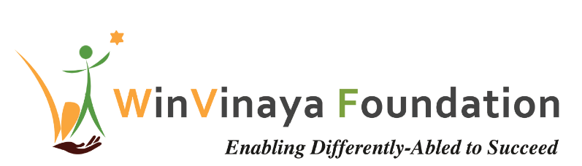

____________________________________________________

Employability Training Program

For Persons with Disability in Bangalore, Karnataka

Proposal by

WinVinaya Foundation

To

American India Foundation (AIF)

Date of Proposal: 01st June 2020

Version 1.0

Project Contact: Sivasankar Jayagopal

Founder Chairman

WinVinaya Foundation

25/3 Brindavan 3rd Cross, Saraswathipuram

IIM Post

Bangalore 560076

Ph.: +91-96764-33359

Email: [Shiva.Jayagopal@WinVinayaFoundation.org](mailto:Shiva.Jayagopal@WinVinayaFoundation.org)

Table of Contents

Revision History 3

1 Project Summary 4

1.1 Background 4

2 Introduction about WinVinaya Foundation 4

3 WinVinaya’s Solution Approach 4

3.1 Training at WinVinaya Center 4

4 WinVinaya Foundation’s Approach to meet the Training Requirements 5

5 WinVinaya Academy – India’s First Digital Learning Platform for PWDs 7

5.1 Design of WinVinaya Academy 7

5.2 User Experience of WinVinaya Academy 8

5.3 Digital Transformation through WinVinaya Academy 9

5.4 Mock Interview by Experts 9

5.5 Interactive Realtime Dashboards 10

6 Implementation Plan 10

7 Volunteer Engagement 10

7.1 Domain Skill Training/ Soft Skills Training 10

7.2 Mock Interviews 10

7.3 Improve WinVinaya Operations 10

7.4 Connect with employers 10

8 Project Budget Information 11

9 Payment Terms 11

10 Dependencies 11

11 Thanks For The Opportunity 12

12 Appendix – 1 – Details of the Project Budget 13

13 Appendix – 2 – Course Curriculum 14

14 Appendix – 3 – Sample Dashboard of WinVinaya Foundation (2018-19) 15

15 Appendix – 4 – Few Success Stories of WinVinaya’s candidates 16

16 Appendix – 5 – Team Building Games at WinVinaya Foundation 17

# Revision History

| Version | Effective Date | Brief Description of Change | Reference for Change |
| --- | --- | --- | --- |
| 1.0 | 01-Jun-2020 | First Version | N/A |

# Project Summary

## Background

American India Foundation (AIF) intends to sponsor employment training program, focused on IT Job Roles in BFSI domain (Banking, Financial Services and Insurance) for 100 persons with disability (PWD) per year for 3 years in Bangalore, which will enable them to join the industry workforce.

# Introduction about WinVinaya Foundation

WinVinaya Foundation, a Charitable Trust was registered in Feb 2016 by Shiva Jayagopal who is an IT Veteran with 28+ years in IT and Seethalakshmi (Akila) who has 15+ years of experience working with Persons with Disabilities. Our primary aim is to empower Persons with Disabilities, economically disadvantaged and women to earn a decent income and lead a life with dignity by providing life skills and resources. We operate a center in Bangalore and a center in Tirupur.

Based on our industry research, we are extending our courses to Ex-Service Persons and Transgender People so that they can earn a better income and lead a life with dignity.

# WinVinaya’s Solution Approach

WinVinaya Foundation would like to use the current center of operation in Bangalore for providing Training and Placement assistance to Persons with Disabilities.

WinVinaya launched WinVinaya Academy – a digital learning platform tailored for Persons with Disabilities and we will be harnessing that for providing Training. This platform is available on the cloud where students can learn anytime, anywhere.

We will provide blended learning to the candidates – a combination of Digital Learning along with daily mentoring by WinVinaya’s trainers.

Due to COVID-19, operating the training center in full strength is uncertain since the situation is very dynamic and fluid. Hence, we recommend that we do Digital Learning + Remote Coaching along with Digital Learning + Classroom Training (where possible) in our Bangalore Campus.

WinVinaya Foundation will do it’s best to cater to a wide spectrum of disabilities – Locomotor Disabled, Hearing Impaired, Visually Impaired, Intellectually Disabled/ Persons with Mental Illness.

## Training at WinVinaya Center

### Project Goals for Training

* To train 100 Persons with Disabilities per year (Visually Impaired, Hearing & Speech Impaired, Locomotor Disabled, Intellectual Disabled) in Bangalore across 3 years (total: 300 beneficiaries) for IT Job Roles in Banking, Financial Services & Insurance sector – which includes software development, software support, core banking operations, operational/ support roles etc.
* Provide interview opportunities for 80% of trained candidates
* Place 50% of the trained candidates in companies and provide post placement support for a minimum of 3 months

### Focus of Digital Skills Training

* Training in BFSI domain, IT
* Training in Soft Skills
* Basic English Communication
* Basic Aptitude
* Mentoring by experts
* Augmented with Digital Learning Platforms
* Will help the candidates learn very effectively and will help them get a job and progress in life.

Training Course Curriculum is available in Appendix-2

### Location of WinVinaya Training

* Training for the Persons with Disabilities will be conducted in the existing center in Bangalore.
* Persons with Disabilities will have to make their own arrangements for travel, food, accommodation. In very special cases (not exceeding 10% of candidates), where candidates are NOT able to afford accommodation & food, it will be paid by WinVinaya Foundation.

# WinVinaya Foundation’s Approach to meet the Training Requirements

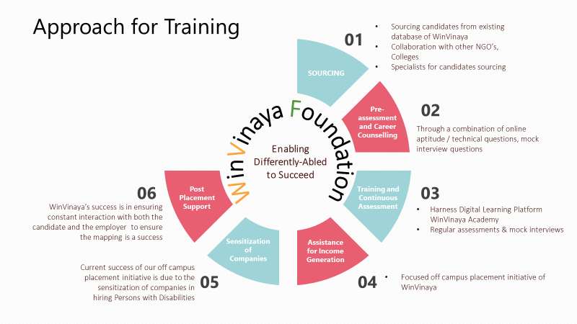**Sourcing of Candidates for training**

* WinVinaya has a database of candidates who can be trained
* WinVinaya collaborates with colleges, NGOs, Specialists, Social Media, Alumni to source the candidates
* The candidates will be a combination of freshers looking for a job or experienced persons who are looking for better career growth

**Screening & Career Counselling**

* WinVinaya will do a pre-assessment of the candidates through a combination of online aptitude/ English/ Technical questions, mock interview questions to assess their knowledge levels, interests, readiness for jobs and provide career guidance.
* Pre-assessment results help us to choose the appropriate training methodology, duration and make it more effective as per the skill of the candidates.

**Training & Skilling**

* WinVinaya has a track record of training 250+ candidates successfully across various streams – IT/ ITES, Soft skills, HR, Finance, Tally.
* WinVinaya integrates games for various team building exercises. Samples are provided in Appendix -5
* WinVinaya will be using WinVinaya Academy – Digital learning platform for class room training, distant learning or a combination of both to provide the training.

**Training Assessments**

* WinVinaya Academy has the capability for online assessments and we will be using that.
* We conduct 2 Mock interviews - One in the middle of the training and another at the end of the training. This helps in assessing the domain skills and soft skills of the candidates in an interview setting, which greatly helps them in clearing real-time interviews.

**Placement / Recruitment**

* Of 250+ trained candidates in the last few years, WinVinaya has a track record of placing about 50% of the candidates. We focus on helping them get the right jobs. The annual salary of the candidates who were placed till now is more than Rs 3.1 Crores.
* WinVinaya’s focused company specific placement drives help in effectively mapping candidates to the recruitment needs of the organizations and facilitate the right placement

**Sensitization of Companies**

* WinVinaya conducts Sensitization Workshop through which we sensitize leaders, managers, team members, Support Teams on the best practices in integrating PWD’s in the workplace. This has helped companies succeed not only in recruiting the candidates but also be successful in embracing them.

**Post Placement Support**

* WinVinaya believes that our part does not end just with placing the candidates. Through our experience we have realized that both Companies and the Candidates need some support, mentoring to ensure that the inclusive journey is successful.
* We provide post placement support to the company and the candidates for minimum 3 months.

# WinVinaya Academy – India’s First Digital Learning Platform for PWDs

Most of the PWD candidates that WinVinaya Foundation has trained in the past are graduates and come from small towns or villages and their knowledge of English is NOT great. There is almost no digital courses available in Sign Language which makes it very difficult for the deaf to learn and be at par with others in the industry. In addition to that, almost all of them lack the “Application of Knowledge” which companies expect from their recruits.

To address these issues, we launched WinVinaya Academy.

## Design of WinVinaya Academy

In WinVinaya Academy, courses are built on “I Am Ready” Framework. We believe that the courses should have a razor sharp focus on helping the candidates get “Ready for jobs” and not just for academic learning.

Less than 5% of the Digital Content are Video Based Learning. 95% of the content are practical. Courses are presented in Simple English and Sign Language (wherever possible).

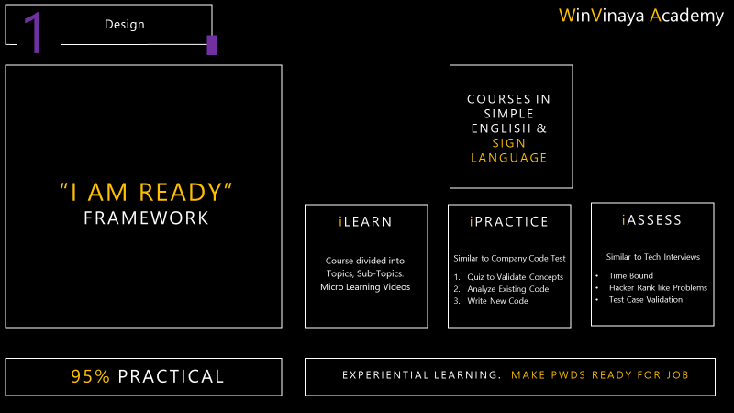

## User Experience of WinVinaya Academy

Every course has 3 modules –

* iLearn (with Micro Learning Videos)
* iPractice (For example, for Java: Quiz, Existing Code Analysis, New Code writing with in-built compiler)
* iAssess (For example, for Java: Within a specified duration, candidates should write new Code for few problems)

Since many IT companies conduct online test, technical interview and then HR interview – Quiz, Code Tests in WinVinaya Academy help them be better prepared for Online Test and Technical Interviews.

In addition to this, trainers can monitor the progress of the candidates through multiple reports – including a Heat Grid which shows the completion % of the candidates – where they are doing well and where they need help. This helps the trainers to coach them accordingly.

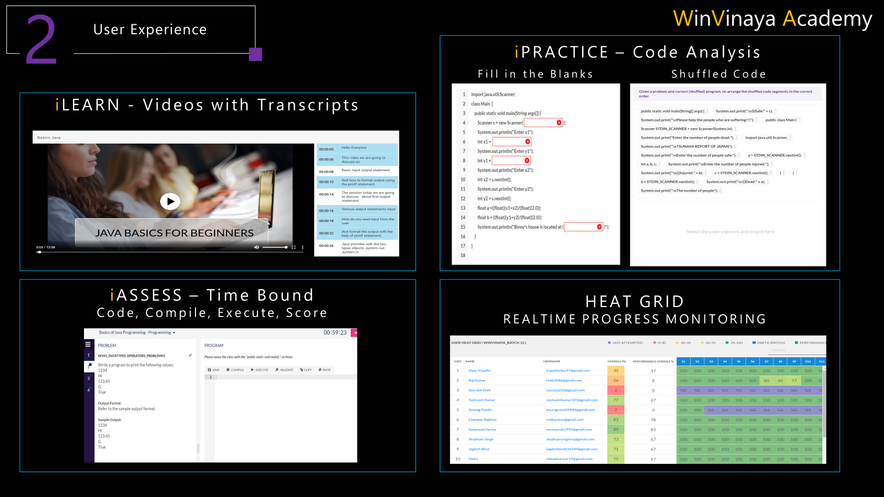

## Digital Transformation through WinVinaya Academy

We believe in the Mantra “Leave No One Behind”.

WinVinaya Academy is hosted on the cloud and is accessible anytime, anywhere.

We noticed that some of our candidates connect to WinVinaya Academy in the night, when their network connection is better, or they are able to borrow laptops from their friends at night. In a traditional instructor led training, this would have been very difficult for some of the candidates to learn in daytime.

In WinVinaya Academy, each course is divided into multiple topics. To ensure that the candidates learn the fundamental topics very well before they move to advanced topics, we open up only few topics at a time. This immensely helps the candidates succeed.

We believe that one size does not fit all, and that Digital Platform alone will NOT solve all the issues in learning. Hence, we have blended learning, where trainers monitor the progress of the candidates daily and have regular calls to coach them.

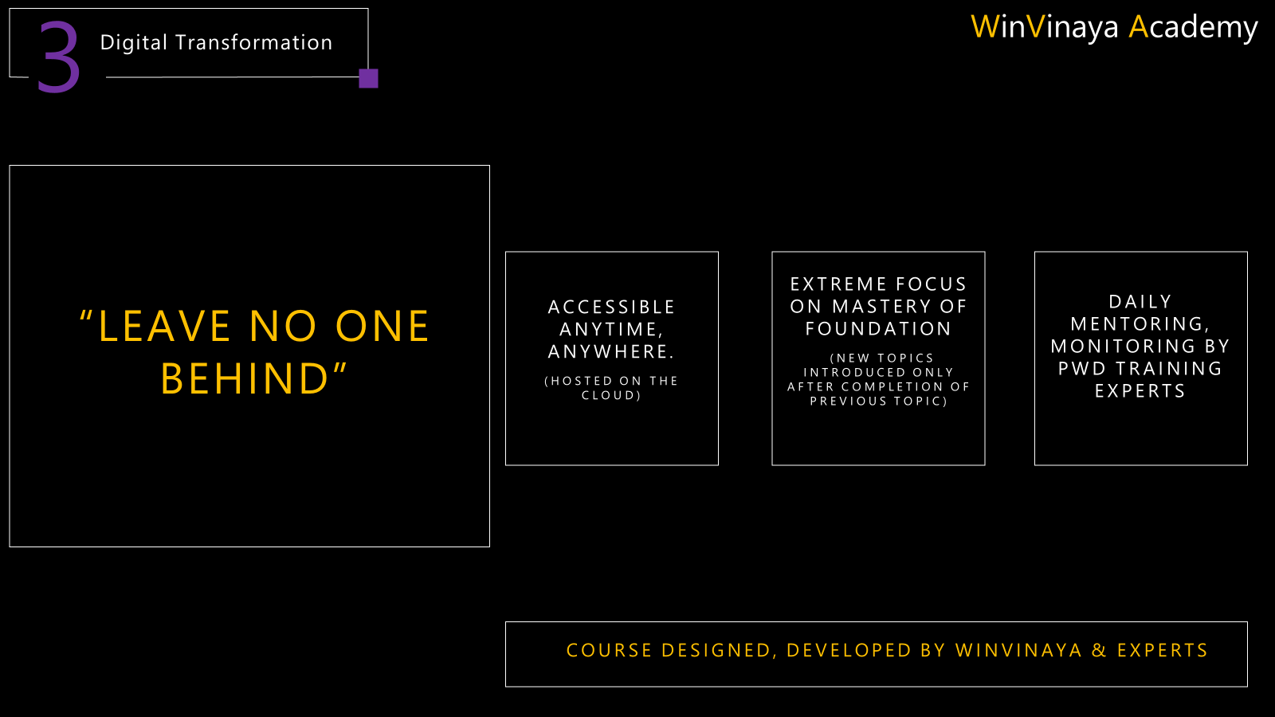

## Mock Interview by Experts

* Expert volunteers from various companies participate in Mock Interviews, provide the requisite guidance to the candidates to succeed
* Their inputs on what they are doing well and what they need to improve along with tips to improve has made a very big difference for the candidates to do well in interviews.

## Interactive Realtime Dashboards

WinVinaya Foundation believes not just in collating the information and reporting on periodic basis, but also in analyzing the information for further improvements. To this end, we built dashboards for Monitoring Training, Placement of candidates. Please see Appendix 3 for the sample dashboard.

# Implementation Plan

|  |  |
| --- | --- |
| Training Location | WinVinaya’s Existing Center in Bangalore |
| No. of Beneficiaries | 100/ year * 3 Years * 1 Location = 300 |
| Duration of the Course | 200 Hours to 300 Hours – approximately 8 weeks to 12 weeks per student  Batch Duration may vary slightly from plan depending on the batch needs and the skill of the candidates |
| Overall Project Duration | 36 months |

# Volunteer Engagement

Employees of American India Foundation (AIF) are most welcome to volunteer and support our initiatives and enable PWDs to lead a life with dignity. There are multiple ways in which volunteers can make a positive impact-.

## Domain Skill Training/ Soft Skills Training

Volunteers can provide training for one or more days on improving domain skills, communication, increasing confidence, interviewing skills, teamwork and more through classroom mode, fun filled games.

## Mock Interviews

Volunteers can be part of mock interviews which helps the candidates to shed their fear and anxiety in facing interviews. Provide authentic feedback on what the candidates did well and where they should improve.

## Improve WinVinaya Operations

Volunteers can help WinVinaya to improve the entire process (from sourcing candidates to placing the candidates to getting funds from sponsors) or selected few key process areas, to significantly increase the social impact.

## Connect with employers

American India Foundation (AIF) can immensely help in the placement of the candidates by connecting WinVinaya to potential employers.

# Project Budget Information

|  |  |  |  |  |  |
| --- | --- | --- | --- | --- | --- |
| **Cost head** | **Description** | **Year-1** | **Year-2** | **Year-3** | **Total** |
| Capex Cost – Enhancing Existing Center (Bangalore) | Additional 10 Laptops, Upgrade of Laptops, Assistive Devices | ₹6,96,000 | - | - | **₹6,96,000** |
| Opex Cost for Bangalore (Existing Center) | Training cost including Rental, Mobilization, Training, Placement | ₹42,54,000 | ₹46,79,400 | ₹51,47,340 | **₹1,40,80,740** |
| **Total** | **Training Budget** | **₹49,50,000** | **₹46,79,400** | **₹ 51,47,340** | **₹1,47,76,740** |

More details of the project budget is given in Appendix-1

# Payment Terms

|  |  |  |
| --- | --- | --- |
| **Cost head** | **Release of Amount** | **Amount** |
| Capex Cost – Enhancing Existing Center (Bangalore) | 100% of the amount within a week of signing the agreement | ₹6,96,000 |

|  |  |  |  |  |
| --- | --- | --- | --- | --- |
| **Cost head** | **Release of Amount** | **Year-1** | **Year-2** | **Year-3** |
| Opex Cost | 25% of the budget before the start of the training | ₹ 10,63,500/- | ₹ 11,69,850/- | ₹ 12,86,835/- |
| 30% after completion of training of 50% of the candidates | ₹ 12,76,200/- | ₹ 14,03,820/- | ₹ 15,44,202/- |
| 30% after completion of training of 100% of the candidates | ₹ 12,76,200/- | ₹ 14,03,820/- | ₹ 15,44,202/ |
| 15% after placement of 50 candidates and year end report | ₹ 6,38,100/- | ₹ 7,01,910/- | ₹ 7,72,101/- |
| **Total** | **₹ 42,54,000/-** | **₹ 46,79,400/-** | **₹ 51,47,340/-** |

# Dependencies

WinVinaya requests American India Foundation (AIF) to provide 1 month from the date of agreement to start the engagement.

WinVinaya requests American India Foundation (AIF) to provide the topics, training reference materials to WinVinaya Foundation 2 weeks before the agreement

# Thanks For The Opportunity

Based on our experience, we are confident that we would be able to execute this project as per the expectations of American India Foundation (AIF) in the journey of bringing a positive change in the lives of Persons with Disability.

WinVinaya takes this moment to thank the American India Foundation (AIF) for providing this opportunity for creating a positive impact on our society. Please watch the videos of the success stories of some of our candidates in Appendix - 4. We hope to create more such success stories for the candidates supported by American India Foundation (AIF).

# Appendix – 1 – Details of the Project Budget

**Note**: Taxes where applicable will be extra to the prices mentioned

**Capex for Existing Center (Bangalore)**

|  |  |  |
| --- | --- | --- |
| **Cost head** | **Description** | **Total** |
| Computer Lab | Additional Laptops, Upgrade existing laptops to Windows 10, MS Office | ₹5,36,000 |
| Accessible Devices | 2 Licenses of JAWS/ Other Assistive Devices | ₹1,60,000 |
| **Total** | | **₹6,96,000** |

**Opex Budget for Existing Center (Bangalore)**

|  |  |  |  |  |
| --- | --- | --- | --- | --- |
| **Cost head** | **Description** | **# of Candidates** | **Unit cost** | **Total** |
| Mobilization of candidates | Cost of outreach (travel; meetings & mobilization sessions; social media; internet; counselling, advertisement/flyers; pre-assessment, enrolments). It is estimated that 130 candidates will be sourced, and 100 candidates will complete training. | 130 | ₹ 2,000 | ₹ 2,60,000 |
| Training of candidates | Training cost of 100 PWDs including Rent, cost of accessible study materials, sign language interpreter, building/ enhancing course materials in WinVinaya Academy, Accommodation for some candidates, systems and software, Broadband/ Network, Computer Maintenance, Events like Mock Interview, Certificate Distribution, and retraining wherever needed | 100 | ₹34,500 | ₹ 34,50,000 |
| Job placement | Including arrangements, personnel, sign language interpreter costs | 50 | ₹ 2,000 | ₹ 1,00,000 |
| **Opex Total for Year-1** | | | | **₹ 42,54,000** |
| **10% Increase in Opex for Year-2** | | | | **₹ 46,79,400** |
| **10% Increase in Opex for Year-3** | | | | **₹ 51,47,340** |
| **Total** | | | | **₹ 1,40,80,740** |

# Appendix – 2 – Course Curriculum

**Curriculum for Software Development**

|  |  |
| --- | --- |
| Course | Description |
| Java | Introduction to Java, Language Fundamentals & Data Types, Java Operators, Java Controls, Strings, Arrays, OOPS, Collection Framework, Exception Handling, File Handling in Java, Threads |
| SQL | Introduction to Database, SQL Command Sets, DDL Commands, DML Commands, Clauses, Aggregate Functions, Joins, Date Functions |

**Curriculum for BFSI**

|  |  |
| --- | --- |
| Course | Description |
| Core Banking | KYC, Mortgage Loan, Account Opening, Account Payable |
| Financial Accounting | Accounting Meaning, Purpose; Systems of Accounting; Types & Rules of Accounting, Capital, Cash, Purchase, Sales, Bank, Purchase Return, Sales Return, Commission, Discount, Purchase Order, Sales Order, Invoice, Journal, Trial Balance, Profit and Loss, Balance Sheet, Basics of GST |
| Tally | Introduction, Company Creation, Creating Ledgers and Groups, Inventory Vouchers, Accounting Vouchers, TDS, GST Entries |

**Curriculum for English (Common for Software Development and BFSI)**

|  |  |
| --- | --- |
| Course | Description |
| English | Nouns, Verbs, Questions, Adjectives, Pronouns, Prepositions, Tenses, Email Writing, Work Status, Messaging, Texting, Word Family (Prefix, Suffix), Form Filling, Articles |

**Curriculum for Soft Skills**

|  |  |
| --- | --- |
| Course | Description |
| Soft Skills | Art of Listening & Communication, How to be a good team player, Assertiveness at the work place, How to write your resume, How to prepare for an interview |

# Appendix – 3 – Sample Dashboard of WinVinaya Foundation (2018-19)

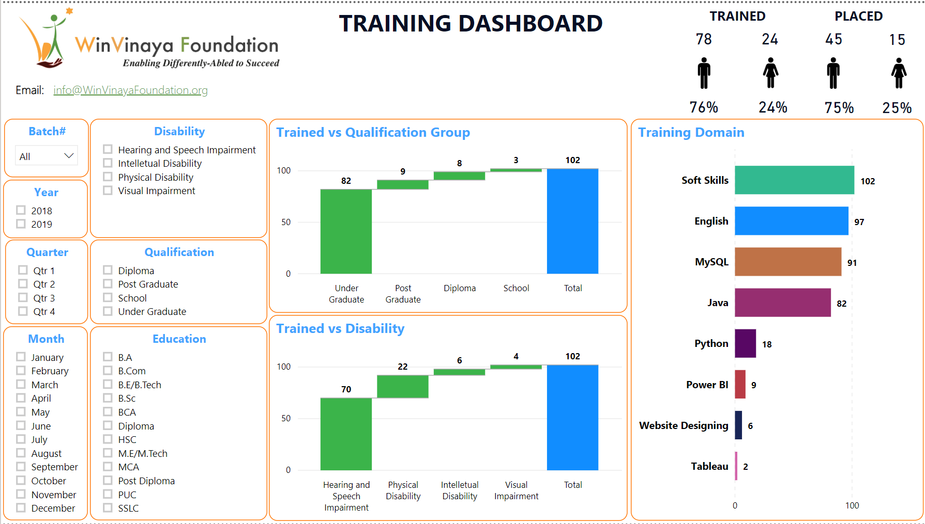

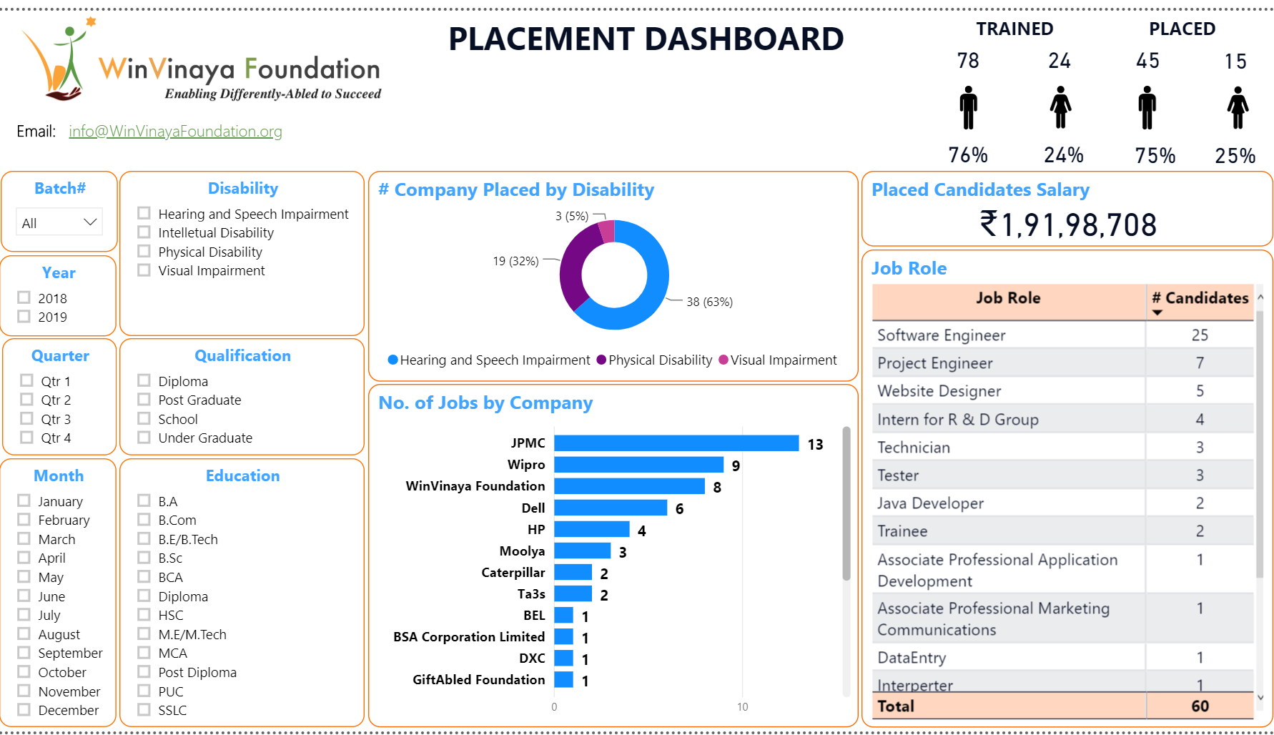

# Appendix – 4 – Few Success Stories of WinVinaya’s candidates

1. **Success Story of Anoop**

Anoop is a Hearing & Speech Impaired person from Kerala. He uses Sign Language to communicate. Even though there are 400+ educational institutions for the deaf in India, almost 95% of them don’t have qualified sign language instructors. In other words, we are NOT educating the deaf in an effective way.

Anoop experienced this the hard way. But then, Anoop is a strong willed, smart, hard working person. Watch this video to see how Anoop transformed his life - [Success Story of Anoop](https://www.youtube.com/watch?v=b-rXnVXsSo4)

1. **Success Story of Lohith**

Lohith is a Person with Low Vision from Karnataka. He wanted to do Engineering, which includes design drawings, practicals, labs… Some raised questions if that is the right course for him. He took it as a challenge and completed Mechanical Engineering.

He then decided to explore the IT sector. He got himself trained in software development and landed a job in a top MNC. When there is a will, there is a way. Watch his story - [Success Story of Lohith](https://www.youtube.com/watch?v=uhxWfwuIVlE&t=148s)

1. **Success Story of Jayashree**

Jayashree is a Person with Locomotor Disability from Karnataka. When she was born, her parents were very worried about the future of their girl child with disability. It was NOT easy to get school admission.

Fast Forward. Jayashree completed MCA. She fine tuned her skills and is now working in a top MNC & is the primary bread winner of her family - A Person with Disability supporting people without disabilities. Watch her story of GRIT – [Success Story of Jayashree](https://www.youtube.com/watch?v=baxYr3XPDPM&t=16s)

# Appendix – 5 – Team Building Games at WinVinaya Foundation

Games are an integral part of learning at WinVinaya Foundation. We harness the power of games to improve self confidence, enhance logical thinking & reasoning, team building skills, leadership building skills.

**Given below are the videos of some of the games played at WinVinaya Foundation.**

**Leadership Building Games -** [**https://www.youtube.com/watch?v=pk7A2fg7Y5A**](https://www.youtube.com/watch?v=pk7A2fg7Y5A) **Team Co-ordination Games -** [**https://www.youtube.com/watch?v=XHyp39KYA4U**](https://www.youtube.com/watch?v=XHyp39KYA4U) **Team Building Games -** [**https://www.youtube.com/watch?v=F_iDYr55HFI**](https://www.youtube.com/watch?v=F_iDYr55HFI)

